

**Student Management App**

Section: L01/L02

Professor: Mahmoud Barhamgi

Members:

Name: Ghanim Alkuwari __ID: 202208523__Efforts Given: 25%

Name: Abdul Wassy__ID: 202211598__Efforts Given: 25%

Name: Mohammed Mansib__ID: 202211429__Efforts Given: 25%

Name: Fahrel Azki__ID: 202206836__Efforts Given: 25%

**Use Case 1: Login**

**Web UI sketches:**

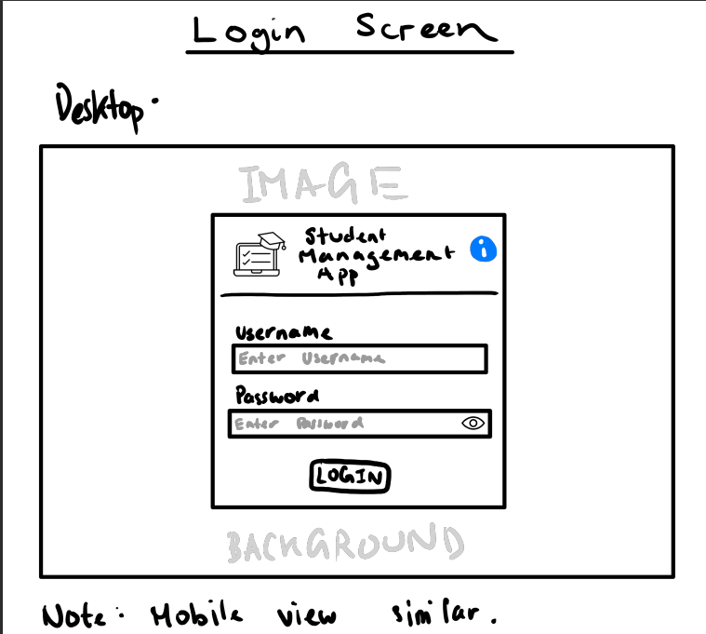

**Web app UI:**

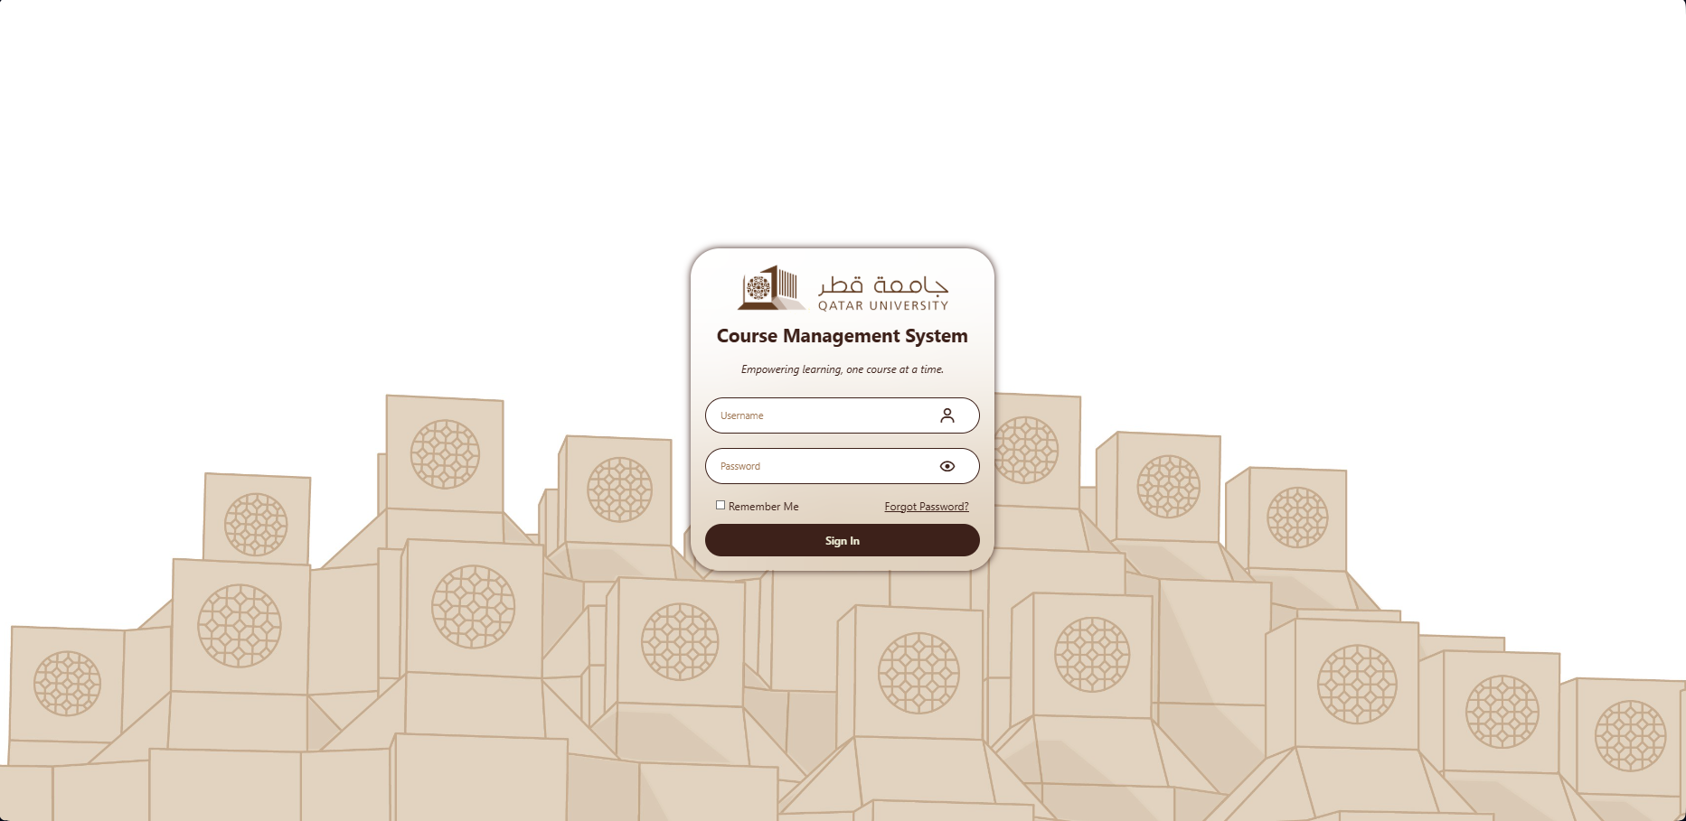

**Use Case 2: Search and display available courses**

**Web UI sketches:**

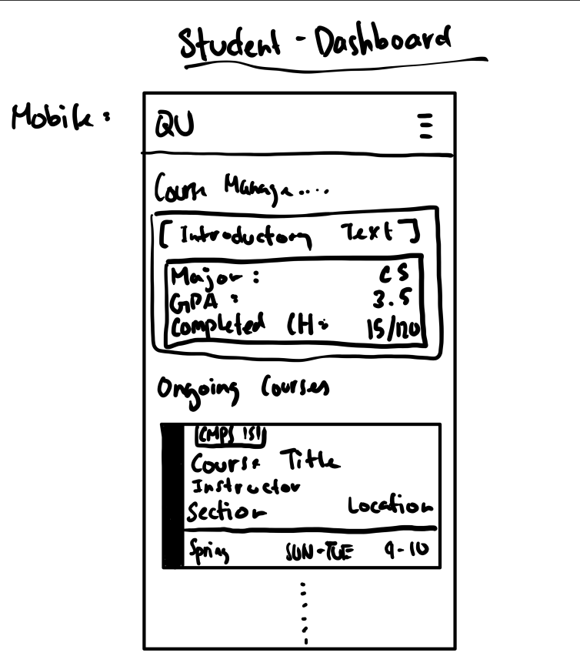

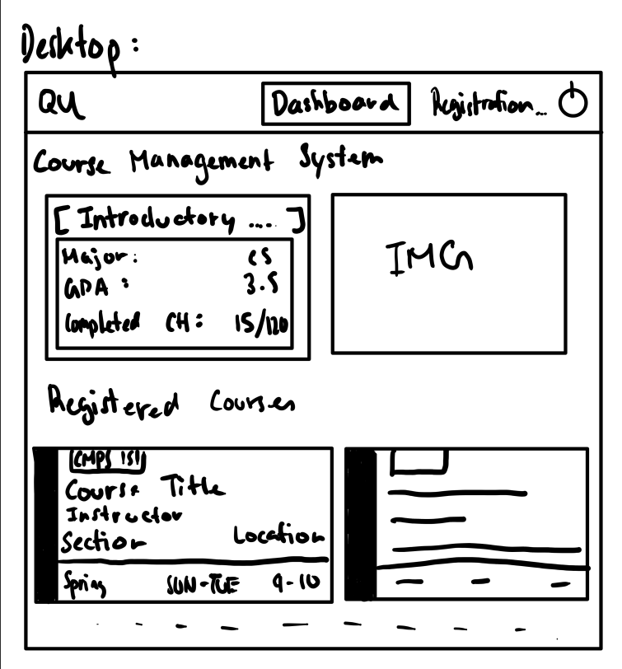

**Web app UI:**

**Desktop:**

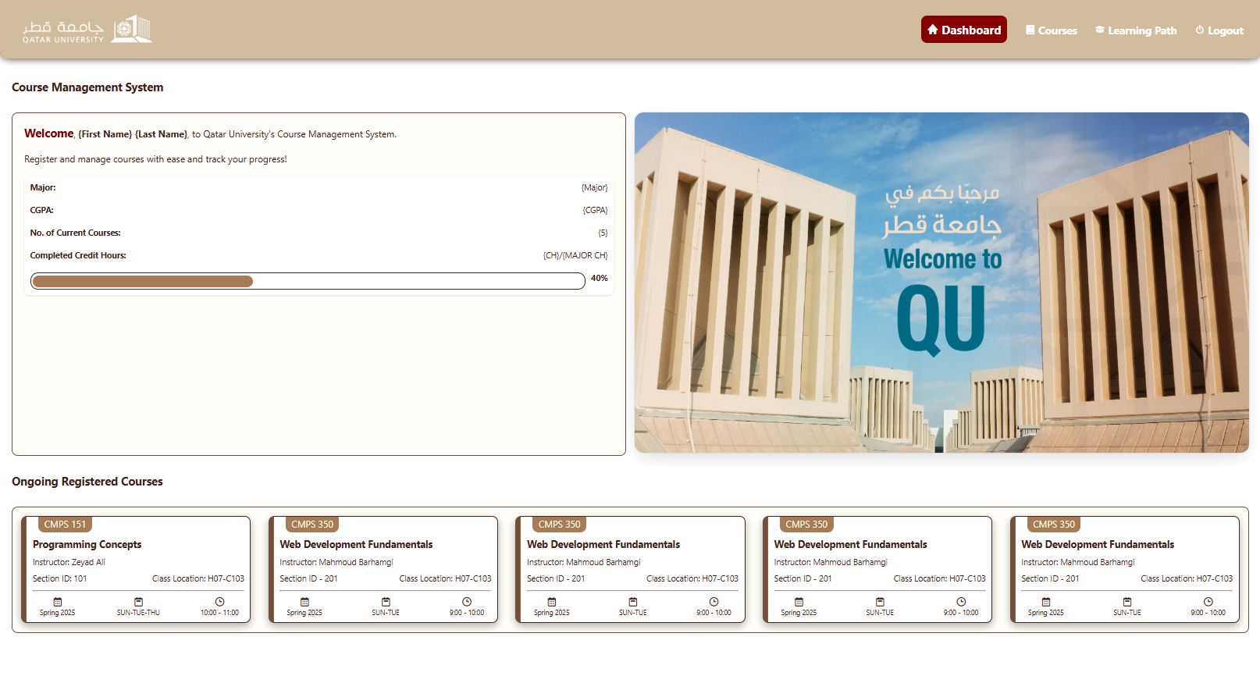

**Mobile:**

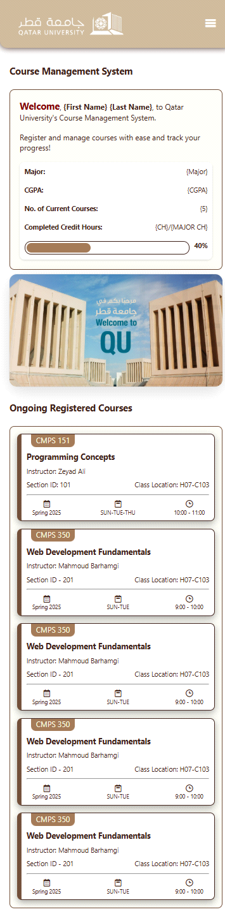

**Use Case 3: Register in a course:**

**Web UI sketches:**

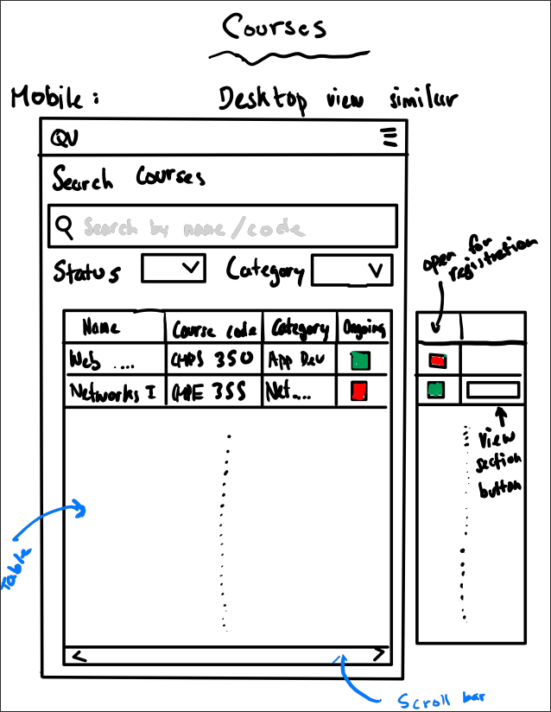

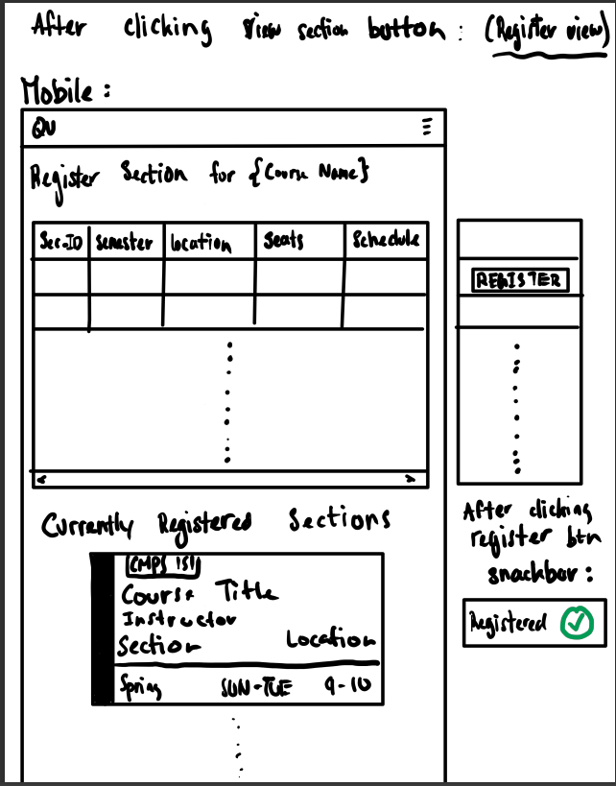

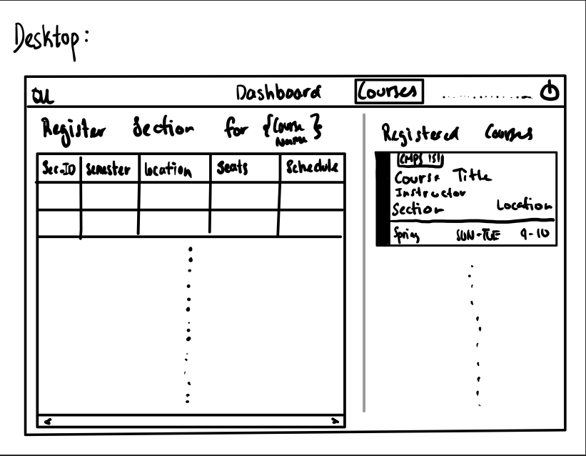

**Web app UI:**

**Desktop:**

**Mobile:**

**Use Case 4: View their learning path:**

**Web UI sketches:**

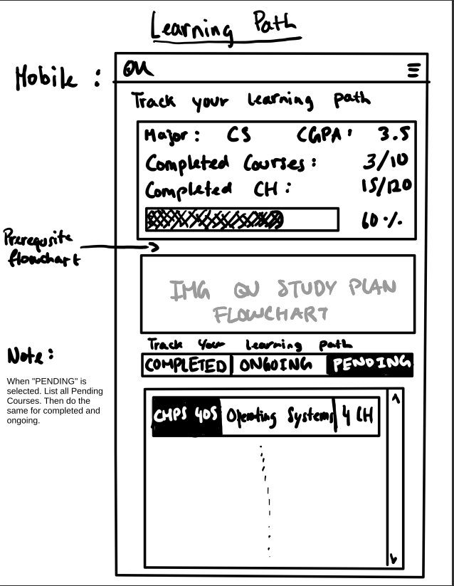

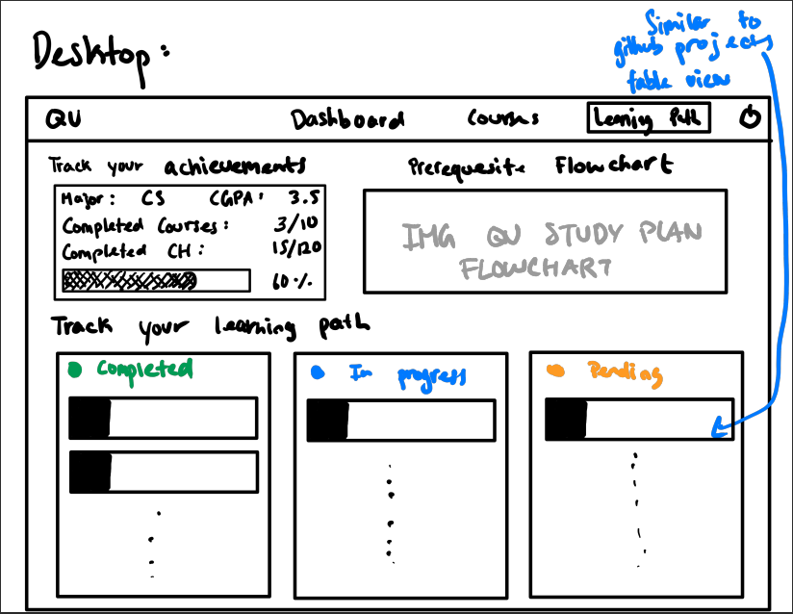

**Web app UI:**

**Desktop:**

**Mobile:**

**Use Case 5: Creating / Validating courses and classes:**

**Web UI sketches:**

**Web app UI:**

**Desktop:**

**Mobile:**

**Use Case 6: Creating / Validating courses and classes:**

**Web UI sketches:**

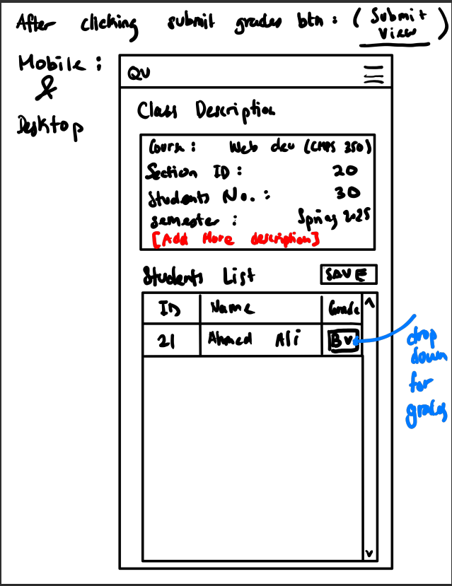

**Web app UI:**

**Desktop:**

**Mobile:**

**Use Case 7: Couse-instructor assignments:**

**Web UI sketches:**

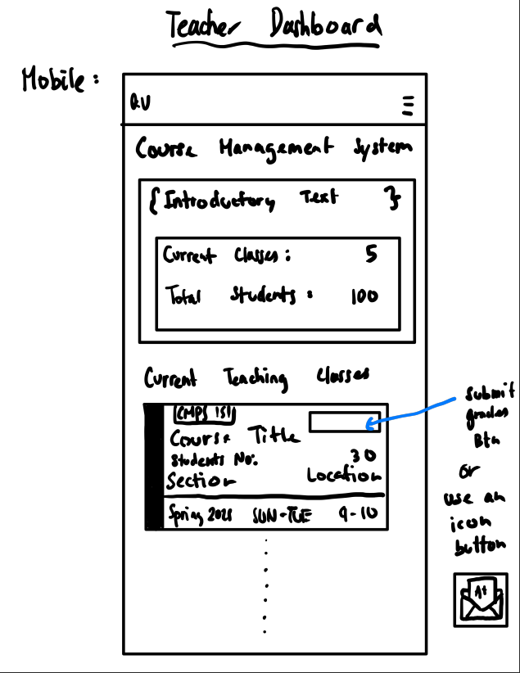

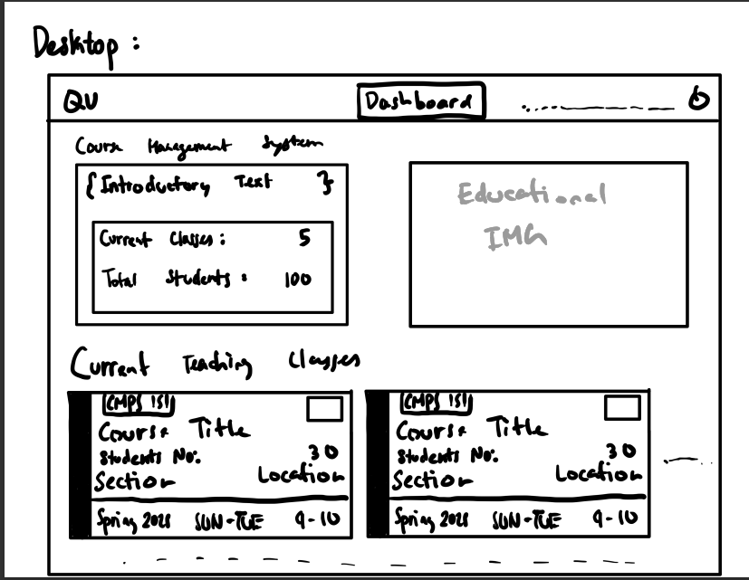

**Web app UI:**

**Desktop:**

**Mobile:**